Title Title Title Title Title Title

N. SURNAME¹, N. SURNAME^{1,2}, N. SURNAME³
¹Institute, Address, City, Country
²Institute, Address, City, Country
³Institute, Address, City, Country
Abstract
Abstract Abstract Abstract Abstract Abstract Abstract Abstract Abstract Abstract Abstract Abstract Abstract Abstract Abstract Abstract Abstract Abstract Abstract Abstract Abstract Abstract Abstract Abstract Abstract Abstract Abstract Abstract [1]. Abstract Abstract Abstract Abstract Abstract Abstract Abstract Abstract Abstract Abstract Abstract Abstract Abstract [2]. Abstract Abstract Abstract Abstract Abstract Abstract Abstract Abstract Abstract Abstract Abstract Abstract Abstract Abstract Abstract Abstract Abstract Abstract Abstract Abstract Abstract Abstract.
Keywords: Keyword1, Keyword2, Keyword3

Graphical Abstract
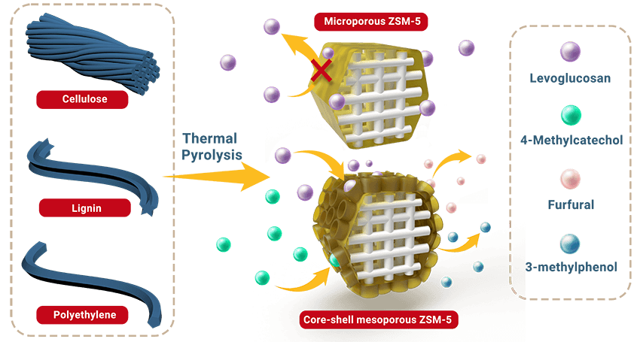

References:
[1] Reference Reference Reference Reference Reference Reference Reference.
[2] Reference Reference Reference Reference Reference Reference Reference.

